**System Description**

A system with three articulated robots are built (Fig.1): two robots each mounted with motorized needle driver and a third robot for holding a mandrel with a stent graft. The mandrel is as Fig 2. which is a fixture with grooves for fixing stent and slots for perfuming sewing. In addition, when illuminated from inside, visible marker will appear on the stent graft surface, and a real-time vision system will be used to identify the exact sewing position. Our stereo vision system is based on two Logitech C930E cameras and calibrated using standard chessboard. The needle drivers are controlled by Faulhaber 2657 DC motors (gearbox 1:14) with MCDC 3006 controller. The communication frequency for the robot and the needle driver are both 1000Hz.

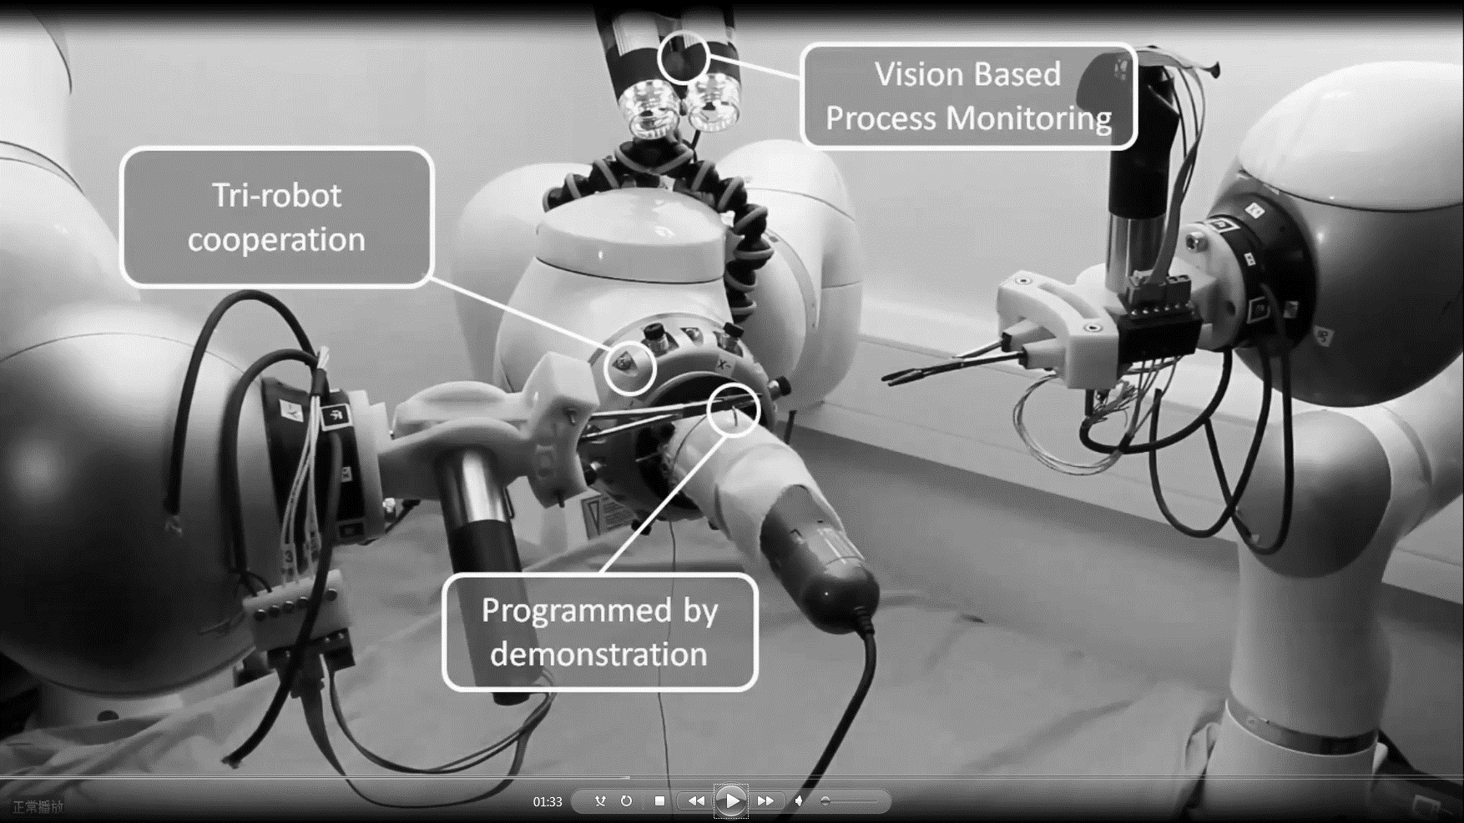

Fig. 1 Multiple Robotic Stent Graft Sewing

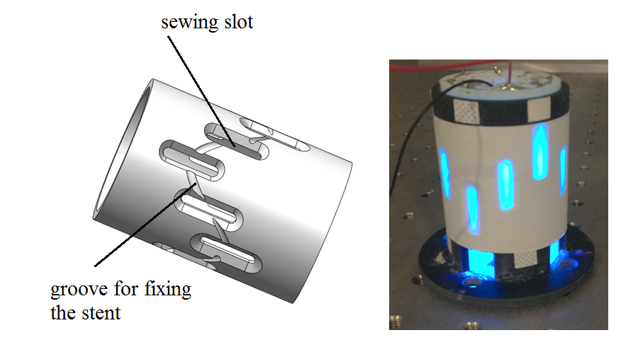

Fig.2 (Left) mandrel CAD design. (Right) Illuminated mandrel